# GLAB 330.2.2 - Standard Deviation

# 

**Introduction:**

**Standard Deviation** **(*σ*)** in statistics, typically denoted by **σ**, is a measure of how much a data set varies (dispersion) between values in a set of data. The lower the standard deviation, the closer the data points tend to be to the mean (or expected value), **μ**. In this lab, we will demonstrate how to calculate the standard deviation.

## Learning Objective:

By the end of this lab learners will be able to calculate the standard deviation.

**Given Dataset**

Imagine that we have the following data set representing the number of books read by five learners in a month:

|  |
| --- |
| **Number of Books (X)** |
| 2 |
| 4 |
| 4 |
| 4 |
| 5 |
| 5 |
| 7 |
| 9 |

**Instructions:**

Here are the steps to calculate the standard deviation:

1. **Calculate the mean (average) of the data set:**



1. **Calculate the squared differences from the mean for each data point:**

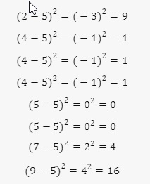

1. **Calculate the average of these squared differences (variance):**

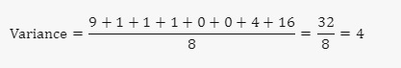

1. **Take the square root of the variance to get the standard deviation:**

## 

The standard deviation of the number of books read by these students is **2**. This means that on average, the number of books read by each student deviates from the mean by **2** books.

**Canvas Submission Instructions:**

* Upload your project to your GitHub account without setting it to private.
* Utilize the `README` file for any necessary additional instructions.
* Incorporate suitable comments throughout your project.
* Share the GitHub link on Canvas by clicking on the "Start Assignment" button located in the top-right corner of the Assignment page.